iDx PC Website and Task Management Report
ITC 4214 Internet Programming | Fall Term 2026
Vasileios Tsevis | Professor Leonardos Mageiros | 10 November 2026
GitHub repository: https://github.com/vtsevis/Internet-Programming-Midterm

Project overview
The iDx P.C. website combines a diagnostics and biotechnology company presentation, product catalogues and a task allocation workspace. Visitors can explore the company and its products, while demonstration users can organise assigned work, monitor deadlines and review progress. This report covers the frontend implementation, coding decisions, testing and future development.
The static submission contains 19 application pages: Home, Tasks, Analytics, About, Contact, a product enquiry page, a manufacturer selection page, two manufacturer profiles, two category selectors and eight product catalogues. HTML provides the structure, locally supplied Bootstrap 5.3.8 and custom CSS provide the layout, and vanilla JavaScript handles interactions and DOM updates.

Task allocation system
Profile | Task access and actions
Administrator | Sees all tasks; creates, edits, completes, moves and deletes them; assigns multiple users; imports and exports backups.
Lecturer | Sees all tasks, filters and Analytics in a read-only view.
Members | See assigned tasks; create self-assigned work and edit, complete or move their assigned tasks. Assignment and deletion remain administrator actions.

Each task stores an identifier, name, description, due date, priority, status, assignee list and timestamps. The statuses are To Do, In Progress and Completed. Pending includes the first two; unfinished tasks with earlier due dates are overdue. A list of assignees supports shared work without duplicating the task.

Persistence and code organisation
Tasks, activity and unsent enquiry receipts persist in localStorage. The selected demo profile uses sessionStorage and expires after eight hours. Data survives reloads while site storage is retained, but remains specific to the browser and origin. Demo profiles demonstrate roles; they are not secure accounts or a shared company database. Administrators can transfer task/activity JSON backups and optionally load 20 fictional sample tasks.
Readable modules separate shared navigation and translations in common.js, profile controls in auth.js, task views in workspace.js, local persistence in browser-service.js, and task/form validation in browser-validation.js. Catalogue and contact modules share product data. Pages load app.bundle.js for distribution, so the submitted site runs on a static HTTP host without a build step.

Tasks page and latest activity

Creating editing and deleting tasks
The Tasks page maintains one state object in workspace.js. refresh() retrieves records for the selected profile and render() derives the table and summary totals. The same dialog supports creation and editing: existing values populate an edit, while an empty identifier creates a new record. Saving finishes before the views refresh, so the interface does not report an unsaved change as successful.
Validation trims text and requires a task name of 1–120 characters and a description of 1–2,000 characters. Due dates must be valid calendar dates in YYYY-MM-DD format. Status and priority values come from fixed lists, and assignees are normalised and deduplicated. Native form checks run before local validation; the Save button is disabled while saving and errors remain visible in the dialog. Completion changes the status to done; deletion requires confirmation.

Filtering sorting and rendering
filteredTasks() combines live name/description search with status and priority filters. It creates a new array, then sorts by name using localeCompare or by due date with name as a tie-breaker. ISO date strings sort chronologically. Filtering affects the view, not saved records. Clicking a summary total selects its status group and clears the other filters.
renderTable() creates DOM nodes and sets textContent rather than interpreting task text as HTML. A DocumentFragment groups rows before replaceChildren updates the table. Expandable descriptions keep rows compact. Row clicks ignore buttons, links and selected text, preventing an Edit or Delete action from accidentally toggling the description. Task-specific accessible names identify action buttons; the lecturer has no editing controls.
The local service reads the latest stored state before each change and uses Web Locks where available to serialise writes from tabs. Invalid backups, corrupt saved data and storage failures are reported. Import validates the complete backup before replacing tasks/activity and preserves enquiry receipts. Without Web Locks, simultaneous tab writes remain a limitation.

Latest activity coding decisions
Each successful task change records an action, task identifier, task-name snapshot and timestamp within the same storage mutation. New entries are prepended and the latest 100 are retained. Home displays the newest six. A transition to done becomes completed; another status change becomes moved; an edit without a status change becomes updated. A name snapshot makes deletion events understandable after the task is removed.
The lecturer and administrator see all activity. Members see events associated with their currently assigned tasks, so deleted or reassigned-away tasks disappear from that member’s feed. renderActivity() uses translated action labels and time elements, formatting timestamps with Intl.DateTimeFormat in Europe/Athens. Empty activity has an explicit message, and window focus refreshes the workspace.

Public API integration
The signed-in Home page fetches EUR reference rates for USD and GBP from Frankfurter. loadRates() uses fetch with a ten-second timeout and checks the response, currency names, numeric rates and dates. renderRates() uses locale-aware currency formatting and displays the rate date. Loading, unavailable and retry states keep the feature understandable; an external API failure does not prevent local task management.

Analytics and the public website

Chosen additional page and Kanban board
Analytics is the chosen additional page. It adds a completed/pending bar chart, a completion progress indicator and the next three unfinished tasks ordered by due date. renderAnalytics() derives these components from the same task state used by the table. Counts of zero produce zero-width bars and zero percent completion, avoiding division by zero. Text labels and a chart description accompany the visual information.
renderBoard() groups cards into todo, doing and done columns and sorts them by due date. Dragging transfers the task identifier; a valid drop calls moveTask() to save the status and refresh all views. A guard prevents overlapping moves, and failures restore the existing view with feedback. Each editable card also has a labelled status selector for keyboard and touch users. Read-only users receive neither dragging nor move controls.

Home About and product browsing
Home introduces the company, its services and manufacturers, and links to the workspace. About includes company information, Vasileios Tsevis’s profile and LinkedIn link, and a manually controlled carousel. Previous and Next change the active slide and announce its position. Manufacturer profiles lead to category selectors and local product catalogues.
ESCO catalogues contain 25 IVF, 27 Clinical Diagnostics, 22 Drug Compounding and 63 Industrial/Applied Sciences cards. bioMérieux contains 72 Hospital/Laboratory, 4 Point of Care, 69 Food Safety/Quality and 34 Pharma Quality Control cards. The total is 316 placements, with some products appearing in multiple categories. Product search combines normalised text terms and application filters, updates the visible count, and provides empty and reset states. Its index refreshes when the language changes.

Contact and product enquiries
Contact includes company details, a form and a Google Map. A separate enquiry page preselects the manufacturer, category and product from catalogue links. Both forms share product data and validate required fields, lengths, email, telephone, country/postcode combinations and catalogue membership. Parent-selector changes clear incompatible child choices; manually edited comments are preserved. Searchable dropdowns support keyboard controls. Submission saves an unsent local receipt and displays its reference inline; no email is sent by the static demonstration.

Responsive design accessibility and localisation
Bootstrap provides the grid, form styles and responsive utilities; custom CSS supplies branding, themes and workspace layouts. The sticky header, active navigation state, hamburger menu, card grids and scrolling task table adapt to smaller screens. SVG wordmarks and emblems switch with the theme. theme.js applies the saved light/dark preference before the main styles to reduce visual flashing.
English, Greek, German and French use shared translation keys. Language changes update visible text, accessible labels, document language, title and metadata; dates, rates and sorting use locale-aware APIs. Semantic landmarks, labelled inputs, alt text, native controls, focus states and keyboard board selectors support accessibility. Local images and relative paths keep the package portable; ASSETS.md records artwork sources. Google Maps and Frankfurter require internet access.

Testing and audit reflection

Functional checks
On 10 November 2026, all eight existing static-submission test groups passed. They cover sessions and demo roles; task CRUD and multiple assignments; validation and persistence; the sample dataset; backup roundtrips; enquiry/postcode validation and all 316 product selections; corrupt or unavailable storage; and the package’s 19 routes, local assets and four languages. Tests used fictional data and did not send enquiries.
Automated browser checks examined Home, Tasks, Analytics, Contact and the Hospital/Laboratory catalogue at widths of 320, 375, 768 and 1440 pixels. None of the 20 combinations showed document-level horizontal overflow. Internal table scrolling is separate from page overflow. Manual keyboard, screen-reader, translated-content and physical-device checks remain useful complements to automated testing.

Lighthouse results
Lighthouse 13.6.0 ran in Chrome 149 on Windows against the submitted static files on 10 November 2026. The local HTTP server used no compression or deployment cache policy. Mobile runs used 412 × 823 emulation with default simulated network throttling and a four-times CPU slowdown; desktop runs used the desktop preset. Each score represents one run. Tasks and Analytics used an administrator profile with 20 sample tasks; public pages were signed out.
Page and mode | Perf | A11y | Best | SEO | LCP
Home mobile | 69 | 100 | 100 | 100 | 5.4 s
Tasks desktop | 98 | 100 | 100 | 100 | 0.8 s
Analytics desktop | 100 | 100 | 100 | 100 | 0.6 s
About mobile | 74 | 100 | 100 | 100 | 4.4 s
Contact mobile | 91 | 100 | 100 | 100 | 2.9 s
Hospital catalogue mobile | 62 | 100 | 100 | 100 | 5.0 s

Scores are out of 100. A11y means accessibility, Best means best practices, and LCP is Largest Contentful Paint. Total Blocking Time was 0 ms throughout. Layout shift was 0.039 on Analytics and 0.159 on the Hospital catalogue, with zero on the other four runs. The following page shows two representative report screenshots.

Evaluation
Desktop workspace performance was strong, but mobile loading was slower, especially Home and the large catalogue. Home transferred approximately 325 kB of JavaScript, 232 kB of Bootstrap CSS, 142 kB for its hero image and 58 kB of custom CSS. Reducing initial CSS/JavaScript, enabling host compression and stabilising catalogue layout are practical next improvements to measure with repeat audits.
All pages scored 100 in accessibility, best practices and SEO, but Home and the catalogue still had a visible-label/accessibility-name diagnostic. Whole-card accessible names need review despite the category scores. These English light-theme local results do not establish complete accessibility or deployed-site performance. Further checks should cover both themes, other languages and the final host under comparable conditions.

Audit screenshots
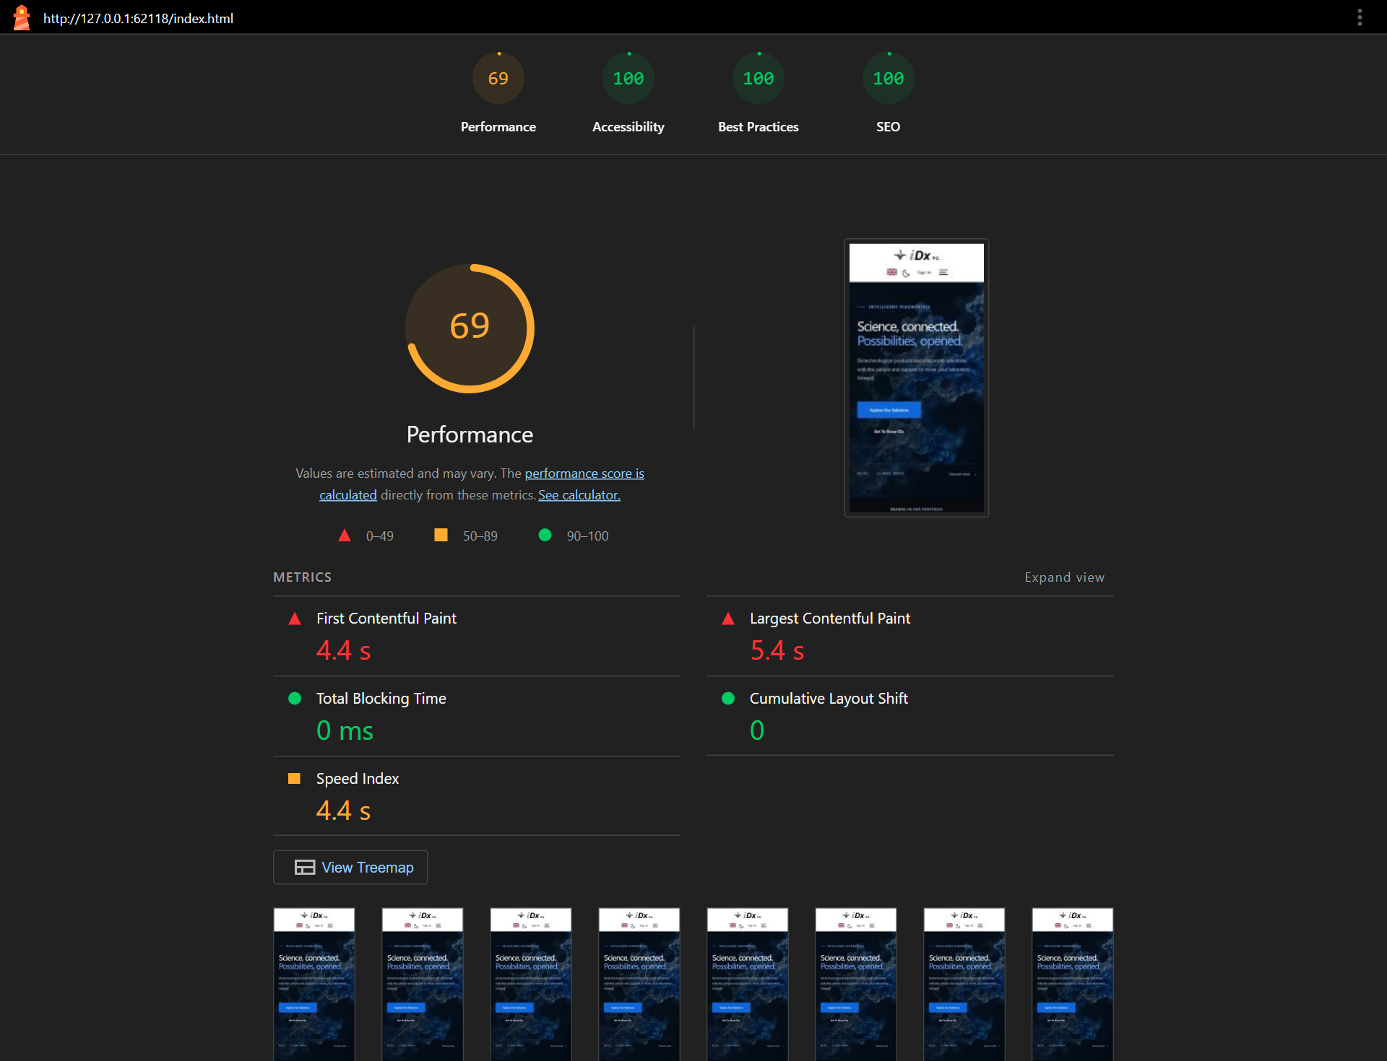
Figure 1 Home mobile audit: performance 69, accessibility 100, best practices 100 and SEO 100.
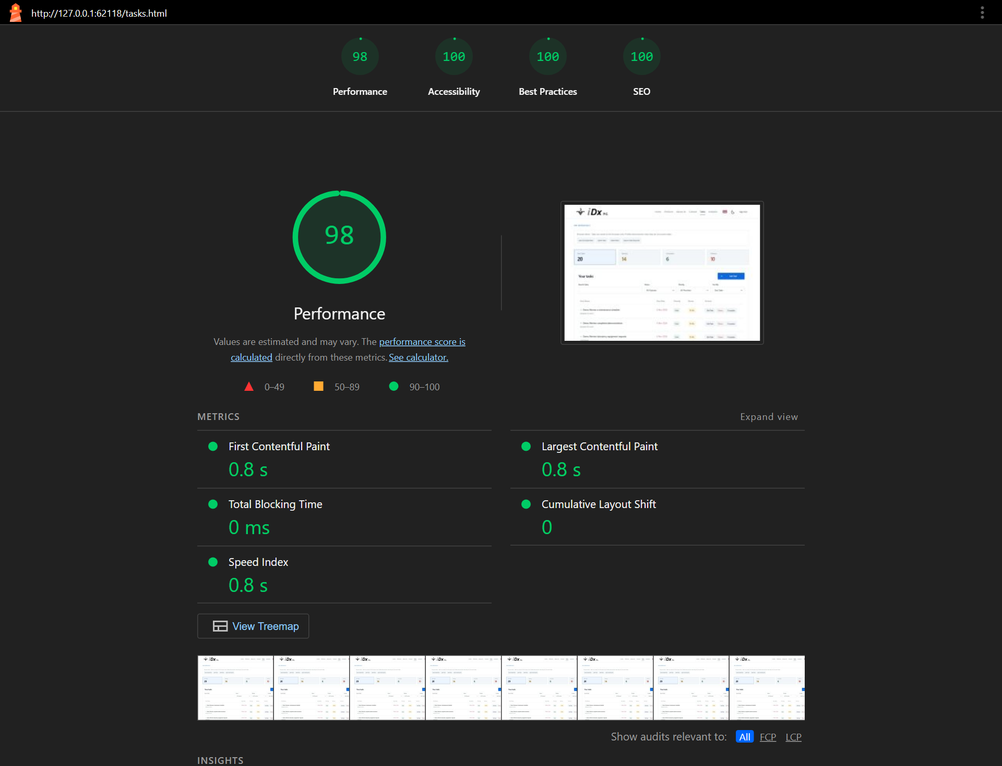
Figure 2 Tasks desktop audit with fictional tasks: performance 98 and the other three category scores 100.

Reflection and future development

Challenges and solutions
Keeping the table, counts, activity and board consistent was a central technical challenge. Saving first and deriving all views from one task state avoids contradictory displays. The same principle applies to the catalogue: reusing product data for browsing and enquiry validation prevents separate lists from drifting apart.
The multilingual interface adds complexity to search, dates, labels and responsive sizing. Shared translation keys, locale-aware formatting and a refreshed search index keep behaviour consistent across languages. Text-only DOM insertion prevents task descriptions from being interpreted as markup, while explicit storage and API error states make failures visible to the user.
The audits show the value of measuring the exact submission package. Good desktop scores do not guarantee fast mobile loading, and a high accessibility score does not remove the need to inspect individual diagnostics. Future frontend improvements should therefore be evaluated with repeatable measurements and manual interaction checks.

Personal reflection
As a cybersecurity student, web development is not my favourite area of study. However, this project challenged me to face gaps in my knowledge and apply concepts that I needed to understand more thoroughly. Working on a complete website brought together structure, styling and JavaScript behaviour in a practical way. It also gave the coursework a purpose beyond college: I was developing something that could support my work at my company (iDx P.C.) and become useful in a real business environment.
One of my biggest realizations was that building the first 90% of a website is often the easier part. Getting the pages and core features working felt more straightforward than making the whole site look and feel polished. Details such as spacing, consistent navigation, responsive layouts and clear form interactions required repeated attention. Although these changes could seem small individually, together they made a substantial difference to the quality of the result.
The project gave me a greater appreciation for the effort involved in producing a professional website. It also showed me the value of testing and refining the user experience throughout development. If I approached a similar project again, I would allow more time for these details and evaluate them earlier. Development may still not be my preferred field, but this experience helped me connect it to practical needs and recognize where I need to keep improving.

Future backend plans
I plan to develop the project into a full website by converting the current PHP backend to Python using Django. This future phase will connect the existing frontend to shared database storage, authenticated accounts, task permissions and enquiry handling. The conversion will be tested before deployment so that task allocation, catalogue browsing and contact workflows continue to work consistently.

Source and references
Bootstrap documentation — https://getbootstrap.com/docs/5.3/getting-started/introduction/
Lighthouse documentation — https://developer.chrome.com/docs/lighthouse/overview/
(Django overview — https://docs.djangoproject.com/en/5.2/intro/overview/)

